**GOVT. PRIMARY SCHOOL , THAVALAKUPPAM**

**Annual Examination 2021-2022**

**Maths**

**Name: Time :** 2 hours

**Std :** V **Marks :** 60

1. **Complete the place value: 5X1=5**
2. 7582 = ____thousands ____hundreds ____tens ____ones
3. 10,000 + 3000 + 500 + 80 + 2 = ______________
4. 13459 =**_________ + __________+ __________+ _________ + _________**
5. 2 thousands + 5 hundreds + 2tens + 2ones **= _____________**
6. _________ + 20 + 1 = 421

**II. Solve the following: 4X3=12**

1. **Add**
2. 6 5 1 3 B) 7 6 5 3

**+** 2 8 9 6 **+** 2 7 0 4

7 3 4 7 1 9 6 8

**_________________ ___________________**

**_________________ ___________________**

1. **Substract**

A) 8 5 2 0 4 B) 9 5 2 6 5

**-** 1 7 5 9 4 - 2 3 4 7 8 **____________________ ___________________**

**____________________ ___________________**

1. **Multiply**

A) 6 7 8 4 3 X 7 B) 3 4 5 6 2 X 64

**________________ _________________**

**III. Match the following: 5X1=5**

1. **Distance – 90**
2. **Pentagon – 1/3**
3. **Right angle – Speed x Time**
4. **Perimeter of a Triangle – 5 Sides**
5. **One-third – a + b + c**

**IV. Choose the correct option: 5X1=5**

1.

2.

3.

4.

5.

**V. Do as directed: 2X1=2**

1) Circle the numbers below which are multiples of 4

22 34 32 28 14 41 44

2) Circle the numbers below which are factors of 20

1 2 5 10 12 20 40

3) Write the multiples:  **2X11/2=3**

a) Multiples of 6: ___, ___, ___, ___, ___, ___, ___, ___, ___, ___

b) Multiples of 5: ___, ___, ___, ___, ___, ___, ___, ___, ___, ___

**VI. Complete the pattern: 5X1=5**



1.



2.



3.

|  |  |  |  |  |  |
| --- | --- | --- | --- | --- | --- |
| **3** | **6** | **9** | **12** |  |  |

4.

|  |  |  |  |  |  |
| --- | --- | --- | --- | --- | --- |
| **20** | **15** | **10** | **5** |  |  |

5.

**VII. Observe the following and answer the questions: 5X1=5**

**Children wrote down weather symbols for each day in March.**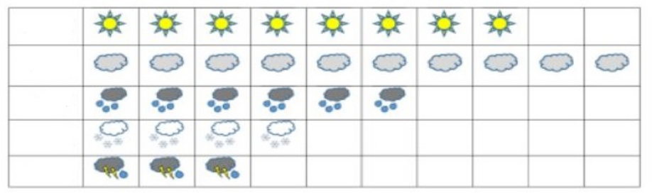

sunny

cloudy

Rainy

Snowy

Stormy

1. How many days was it sunny? 
2. How many days was it rainy? 
3. How many days was it stormy?
4. What was the most common weather?
5. Which sort of weather do you like most?

**VI. Solve the following: 2X4=8**

1.A school library has 3,730 books in Tamil, 3,303 books in English, and 5,439 books in other languages. How many books are there in library?

2. A shop sold 3248 clocks in 2018. In 2019, 5680 clocks were sold. How many more clocks were sold in 2019?

**VIII. Write the 6th and 7th tables 2X21/2=5**